Lambda : eventbridge-gcp-publisher-rules-preprod-productApiChangedHandler

Change key value of PRODUCT_CHANGED_SQS_URL (before change)

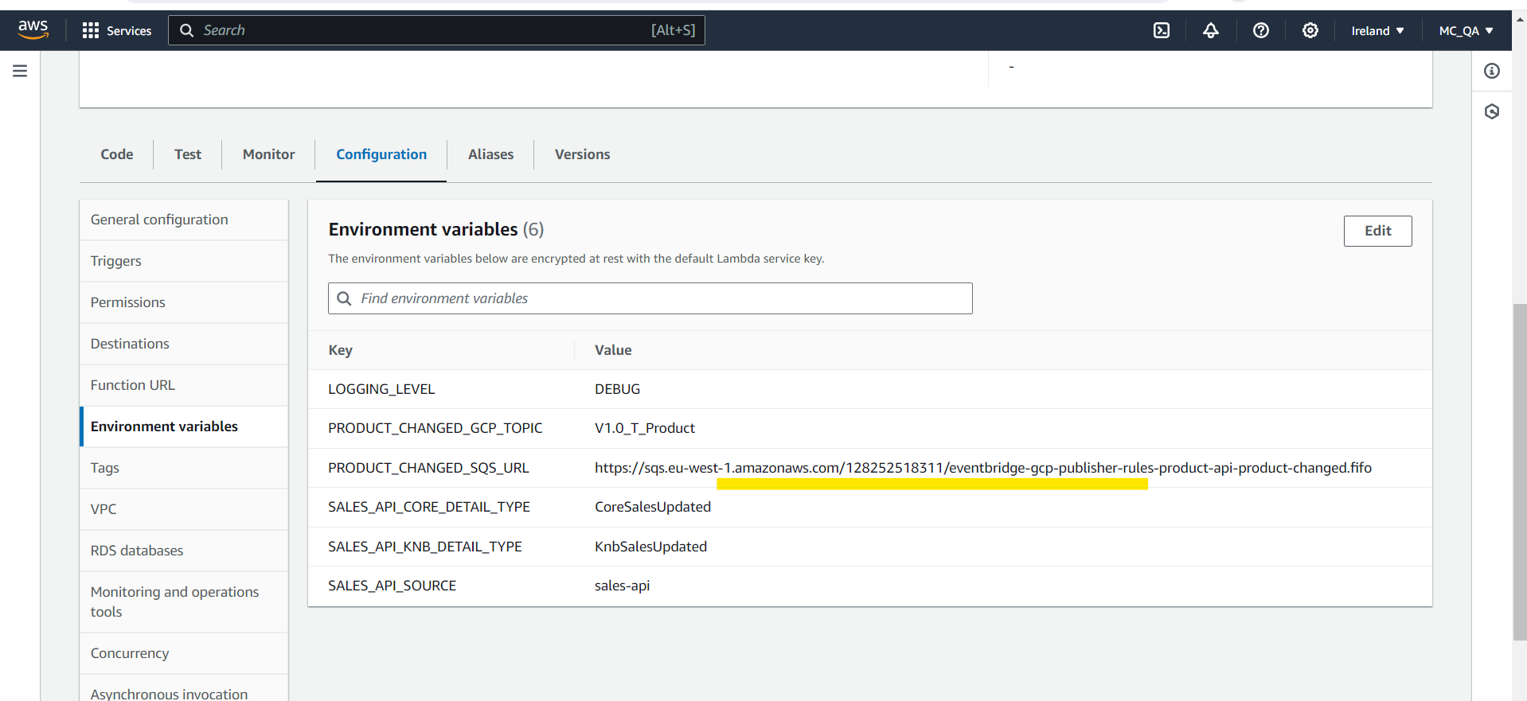

Original value

<https://sqs.eu-west-1.amazonaws.com/128252518311/eventbridge-gcp-publisher-rules-product-api-product-changed.fifo>

value changed:

Hi Postman request:

Lambda :

eventbridge-gcp-publisher-rules-preprod-productApiChangedHandler logs

<https://eu-west-1.console.aws.amazon.com/cloudwatch/home?region=eu-west-1#logsV2:log-groups/log-group/$252Faws$252Flambda$252Feventbridge-gcp-publisher-rules-preprod-productApiChangedHandler/log-events/2024$252F07$252F04$252F$255B$2524LATEST$255Da35b3561d7994762a51fcde79cac9fba>

handler datadog logs

<https://app.datadoghq.com/logs?query=service%3Aeventbridge-gcp-publisher-rules-preprod-productapichangedhandler%20&agg_m=count&agg_m_source=base&agg_t=count&cols=host%2Cservice&fromUser=true&messageDisplay=inline&refresh_mode=sliding&storage=hot&stream_sort=desc&viz=stream&from_ts=1720075811665&to_ts=1720076711665&live=true>

No logs in datadog for : gcp-publisher-preprod-genericSqsToGcp

<https://app.datadoghq.com/logs?query=service%3Agcp-publisher-preprod-genericsqstogcp%20&agg_m=count&agg_m_source=base&agg_t=count&cols=host%2Cservice&fromUser=true&messageDisplay=inline&refresh_mode=sliding&storage=hot&stream_sort=desc&viz=stream&from_ts=1720075811665&to_ts=1720076711665&live=true>

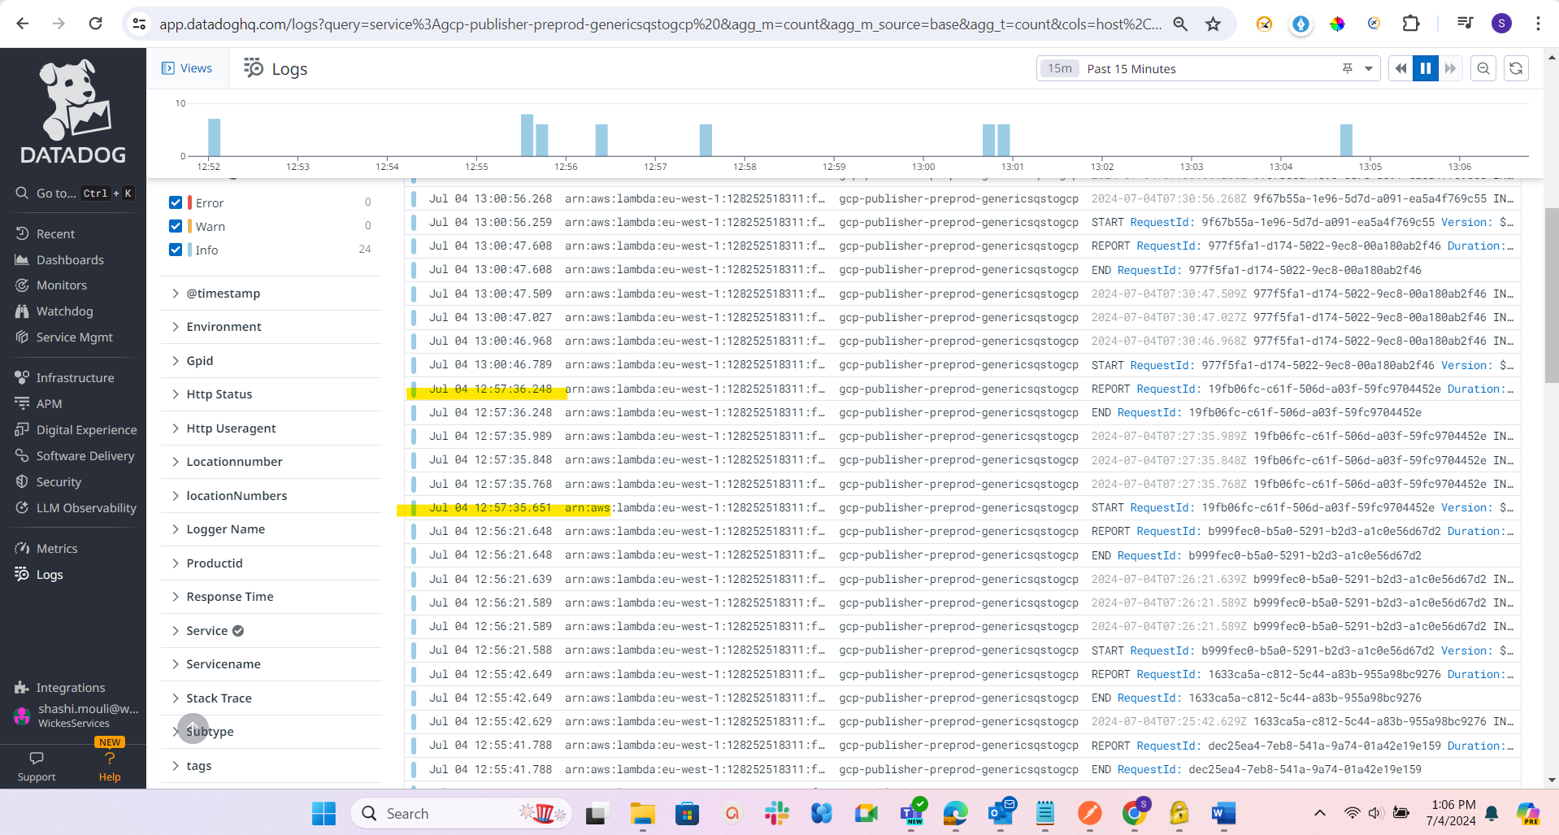

Handler environment variable changed back

